

**DEPARTMENT OF COMPUTING**

**ISYS224 2019 S2 – ASSIGNMENT ONE (25%)**

**Due: 11:55am Monday 16 September 201****9**

**Database Design & Implementation**

Please Print Clearly In **CAPITALS**

|  |  |
| --- | --- |
| **Surname** | **LAM** |
| **First Name** | **JUSTIN x`** |
| **Student ID** | **45197083** |
| **Signature** |  |

#### **Student Code of Conduct**

Macquarie University students have a responsibility to be familiar with the Student Code of Conduct: [https://students.mq.edu.au/study/getting-started/student-conduct​](https://students.mq.edu.au/study/getting-started/student-conduct)

### Student Support

Macquarie University provides a range of support services for students. For details, visit <http://students.mq.edu.au/support/>

**Task 1: Conceptual Data Model**

*Justifications:*

* *Relationships:*

1. *There is a one to many relationship between staff and supervisor – as each supervisor can supervises one or more staff while one staff can supervise by only one supervisor.*
2. *There is a many to many relationship between staff_works_campaign and campaign – each campaign can be worked by multiple staffs and each staff can works ion multiple campaign.*
3. *There is a many to many relationship between staff and campaign – which means that many staff members can overseas many campaigns and vice versa.*
4. *There is a one to many relationship between campaign and advert as one campaign can have multiple adverts, on the other hand one advert should belong at most one campaign. The same advert (the name, type) cannot be implemented in two different campaigns.*
5. *Similarly, there is a one to one relationship between campaign and invoice as a campaign will only have one associated invoice and one invoice will be issued to one campaign.*
6. *There is a one to many relationship between client and invoice – this means that each client will receive one or more invoices while one invoice can only receive by at most one client.*
7. *There is a many to many relationship between advert and studio – where many adverts can be booked in many studios and vice versa.*
8. *There is a one to many relationship between full time staff and client: as a full time staff can contact many clients however one client will only be contacted by one staff member at a time. It is important to note that casual staff members cannot manage campaigns.*
9. *There is a one to many relationship between client and campaign – which means that a client can have multiple campaigns while one campaign belongs to at most one client.*

* *Generalisation/Specialisation* 
  1. *There is only one specialisation case in the above as a staff can be either a full time or casual. Unlike full time staff, casuals do not own a permanent office in the agency and they are contacted via phone number. As a result, casual ID is only attribute exists in the casual entity. On the other hand, office ID and office location is apparent in the full time entity – as this can be shown above.*
* *Weak entities.* 
  1. *Weak entities can be defined as an entity that cannot be uniquely identified by its own attribute. An example of weak entity is the staff_works_campaign as it closely links to campaign. If the entity is removed then we cannot identify which campaign is the staff working.*
  2. *Likewise, booking is also one of the associated entity as both entities advert and studio need to be created before in order to create a booking.*
* *Associated entities:*
  1. *Advert and Studio.*
  2. *Staff works campaign and campaign.*
  3. *Staff and supervisors.*

*Assumptions:*

1. *A supervisor is not part of a staff – however many supervisors will supervise many staff(s) directly.*
2. *A staff will gets a salary – in which it contains a salary grade and the annual salary (which only applies to full time staff). Unlike full time, casual staff will only have a staff work hourly rate and work time as this is shown in the casual entity above.*
3. *An assumption is made that a full time will receive an employment contract in which it contains an employment contract ID to uniquely distinguish the full time and its contract.*
4. *Since there is a many-to-many relationship between advert and studio, as a result, we do not need create a separate entity for booking (we can simply use that as a relationship name). This is due to the fact that an associated entity will be created in relational data model (task 2).*

**Task 2: Relational Schema**

***Supervisor*** *(Supervisor ID, Supervisor First Name, Supervisor Last Name, Supervisor Phone Number, Is Manager?)*

*Primary Key Supervisor ID*

*Alternative Key Supervisor Phone Number*

***Staff*** *(Staff ID, Staff First Name, Staff Last Name, Gender, Staff DOB, Staff Phone Number, Staff Email Address, Staff Positon)*

*Primary Key Staff ID*

*Alternative Key Staff Phone Number, Staff Email Address*

*Foreign Key Campaign ID references Campaign (Campaign ID)*

***Full Time*** *(Staff ID, Staff First Name, Staff Last Name, Gender, Staff DOB, Staff Phone Number, Staff Email Address, Staff Positon, Office ID, Office Location, Client ID)*

*Primary Key Staff ID, Office ID*

*Alternative Key Staff Phone Number, Staff Email Address*

*Foreign Key Client ID references Client (Client ID)*

***Casual*** *(Staff ID, Staff First Name, Staff Last Name, Gender, Staff DOB, Staff Phone Number, Staff Email Address, Staff Positon, Casual ID)*

*Primary Key Staff ID, Casual ID*

*Alternative Key Staff Phone Number, Staff Email Address*

***Client*** *(Client ID, Client Name, Client Email Address Client Address, Staff ID)*

*Primary Key Client ID*

*Alternative Key Client Email Address*

*Foreign Key Staff references Staff ID*

***Campaign*** *(Campaign ID, Campaign Name, Campaign Theme, Campaign Estimated Cost, Campaign Actual Cost, Campaign Estimated Start Date, Campaign Estimated Finish Date, Campaign Actual Start Date, Campaign Actual Finish Date, Client ID)*

*Primary Key Campaign ID*

*Alternative Key Campaign Theme, Campaign Name*

*Foreign Key Client ID references Client (Client ID)*

***Advert*** *(Advert ID, Advert Type, Campaign ID)*

*Primary Key Advert ID*

*Foreign Key Campaign ID references Campaign (Campaign ID)*

***Studio*** *(Studio ID, Studio Name, Studio Location, Studio Status, Advert ID)*

*Primary Key (Studio ID)*

*Foreign Key Advert ID references Advert ID*

***Invoice*** *(Invoice ID, Issue Date, Total Cost, Payment Status, Campaign ID)*

*Primary Key Invoice ID*

*Alternative Key Campaign ID*

*Foreign Key Campaign ID references Campaign (Campaign ID)*

***Staff Works at Campaign*** *(Salary Grade, Is fulltime? Annual Pay, Hourly Pay, Staff ID, Campaign ID)*

*Primary Key Staff ID, Campaign ID*

*Foreign Key Staff ID references Staff (Staff ID)*

*Foreign Key Campaign ID references Campaign ID*

**How to translate the conceptual data model into the logical data model?**

1. Derive relations for logical data model.
   1. For example: Staff (Staff ID, Staff First Name, Staff Last Name, Gender, Staff DOB, Staff Phone Number, Staff Email Address, Staff Positon) 🡪 Staff ID.
2. Identify which entitles are strong and weak.
   1. In this instance, we can concluded that Staff is a strong entity as in can be existed by itself while the entity: staff_works_campaign is weak as need to have both campaign and staff information in order to have such entity. If staff or campaign entity being deleted then such entity will not be able to exist.
3. Find out the one-to-many and one-to-one relationship.
   1. Based on the scenario above, it shows that there is a one to many relationship between full time staff and campaign.
   2. On the other hand, there is a one to one relationship between invoice and campaign – as one invoice should belong to at most one campaign.
4. It is important to note that superclass/subclass relationship will not be included in the logical data model. However it is worth knowing that, staff can either a full time or casual staff in this (Shine) scenario.
5. Find out many to many relationship of the scenario. In this instance, it’s the staff_works_campaign and campaigns. As many staff can work in many campaign therefore this relationship is valid.
6. Complex relationship types will create foreign keys. Foreign keys are not shown in the conceptual model therefore we need to state them in logical data model. For instance advert entity has a foreign key of campaign ID – which references the PK of the campaign table.
7. Validate relations using normalization. This will be done in the upcoming task (Task 3).
8. Validate relations against user transactions to see whether the relations in our model support required transactions.
9. Check integrity constraints within the model. Referential integrity is highlighted to be one of the most constraints to ensure complete data in return.

**Task 3: Logical data model/Functional Dependency/Normalisation**

**Staff (Staff ID, Staff First Name, Staff Last Name, Gender, Staff DOB, Staff Phone Number, Staff Email Address, Staff Positon)**

Staff ID 🡪 Staff First Name, Staff Last Name, Gender, Staff DOB, Staff Phone Number, Staff Email Address, Staff Positon (Functional Dependency)

Staff table is 2NF (2nd Normalised Form) because there are transitive dependencies in the relation therefore it cannot be 3NF>

**Client (Client ID, Client Name, Client Email Address Client Address, Staff ID)**

Client ID 🡪 Client Name, Client Email Address Client Address (Functional Dependency)

Client table is 2NF (2nd Normalised Form) because there are transitive dependencies in the relation therefore it cannot be 3NF.

**Campaign (Campaign ID, Campaign Name, Campaign Theme, Campaign Estimated Cost, Campaign Actual Cost, Campaign Estimated Start Date, Campaign Estimated Finish Date, Campaign Actual Start Date, Campaign Actual Finish Date, Client ID)**

Campaign ID 🡪 Campaign Name, Campaign Theme, Campaign Estimated Cost, Campaign Actual Cost, Campaign Estimated Start Date, Campaign Estimated Finish Date, Campaign Actual Start Date, Campaign Actual Finish Date

Campaign Theme 🡪 Campaign Estimated Cost, Campaign Actual Cost, Campaign Estimated Start Date, Campaign Estimated Finish Date, Campaign Actual Start Date, Campaign Actual Finish Date

Campaign table is 2NF (2nd Normalised Form) because there are transitive dependencies in the relation therefore it cannot be 3NF.

**Advert (Advert ID, Advert Type, Campaign ID)**

Advert ID 🡪 Advert Type

Advert table is 2NF (2nd Normalised Form) because there are transitive dependencies in the relation therefore it cannot be 3NF.

**Studio (Studio ID, Studio Name, Studio Location, Studio Status, Advert ID)**

Studio ID 🡪 Studio Name, Studio Location, Studio Status

Studio table is 2NF (2nd Normalised Form) because there are transitive dependencies in the relation therefore it cannot be 3NF>

**Invoice (Invoice ID, Issue Date, Total Cost, Payment Status, Campaign ID)**

Invoice ID 🡪Issue Date, Total Cost, Payment Status, Campaign ID

Campaign ID 🡪 Invoice ID

Invoice table is 2NF (2nd Normalised Form) because there are transitive dependencies in the relation therefore it cannot be 3NF.

**Staff Works at Campaign (Salary Grade, Is fulltime? Annual Pay, Hourly Pay, Staff ID, Campaign ID)**

Staff ID 🡪 Salary Grade, Is fulltime? Annual Pay, Hourly Pay

Staff Works at Campaign table is 2NF (2nd Normalised Form) because there are transitive dependencies in the relation therefore it cannot be 3NF.

**Supervisor (Supervisor ID, Supervisor First Name, Supervisor Last Name, Supervisor Phone Number, Is Manager?)**

Supervisor ID 🡪 Supervisor First Name, Supervisor Last Name, Supervisor Phone Number

Supervisor table is 2NF (2nd Normalised Form) because there are transitive dependencies in the relation therefore it cannot be 3NF.

**Task 4: DDL**

Supervisor Table:

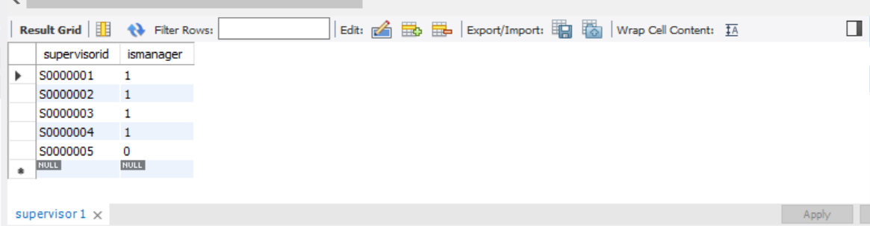

Staff Table:

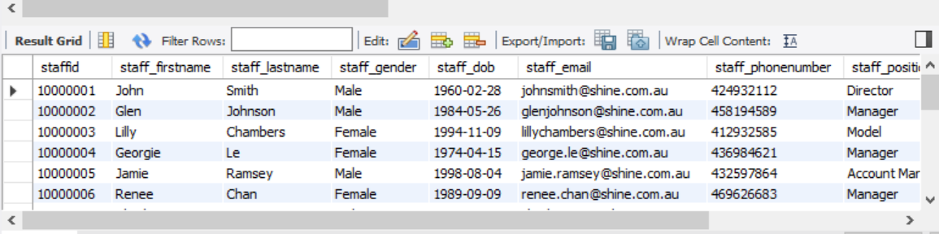

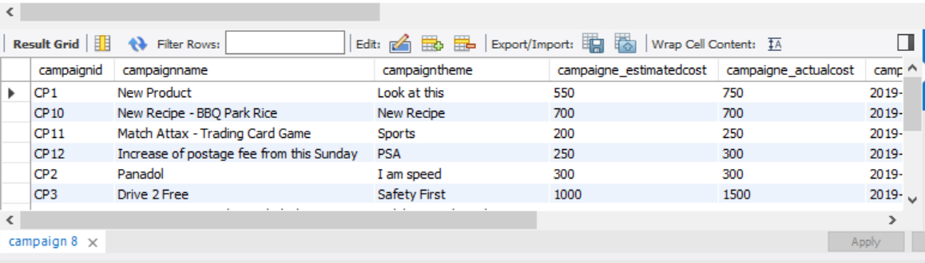Campaign Table:

Client Table:

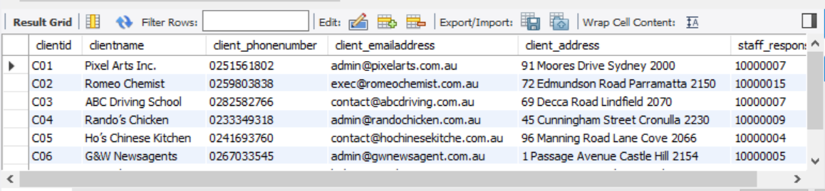

Studio Table:

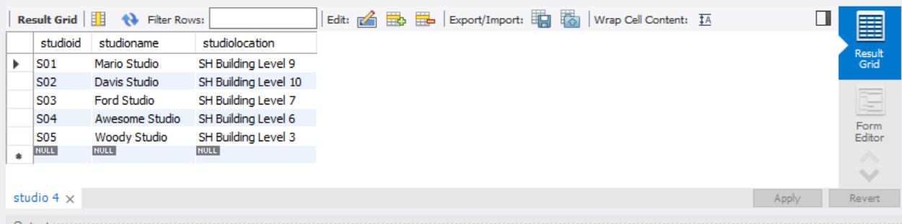

Advert Table:

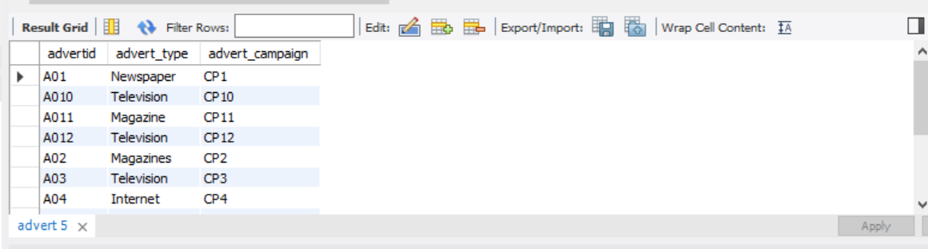

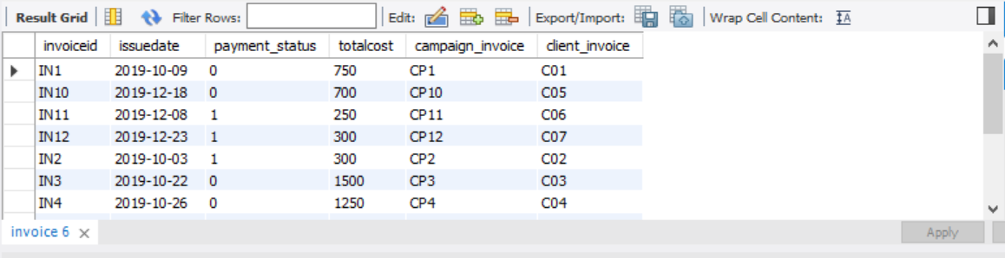Invoice ID:

Staff_Works_Campaign Table

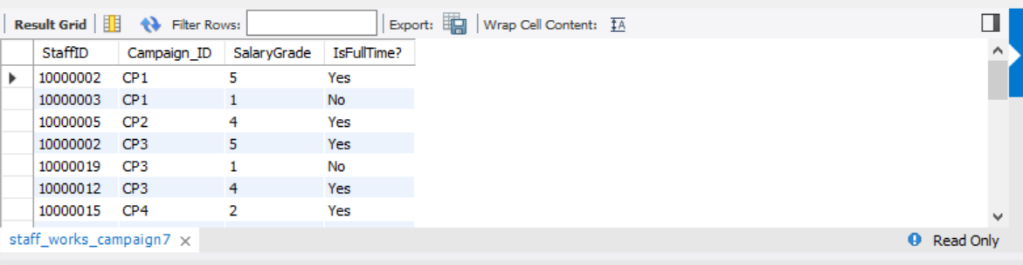

**Task 5: DML**

**Question 1**

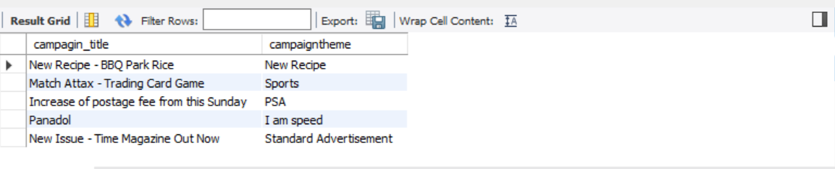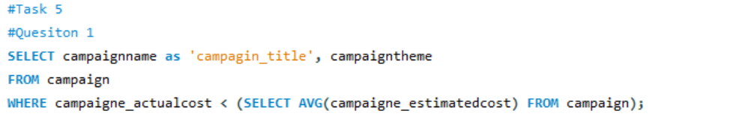

**Question 2**

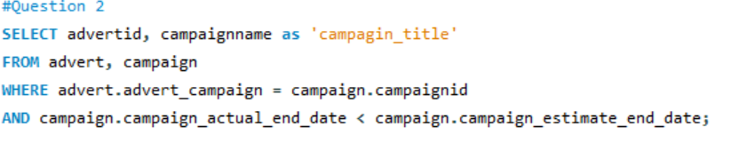

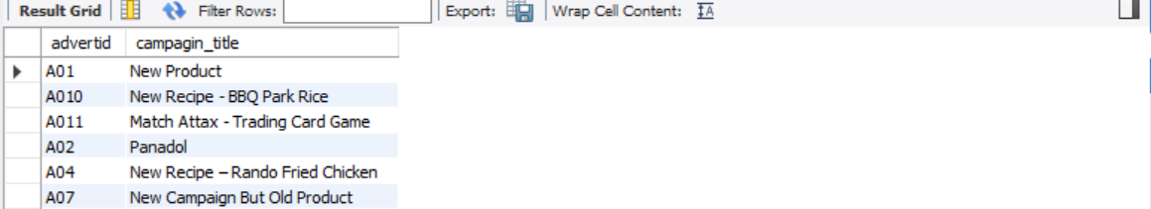

**Question 3**

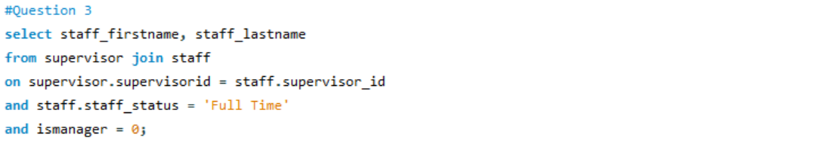

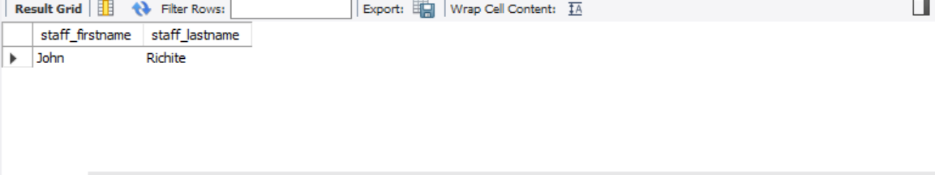

**Question 4**

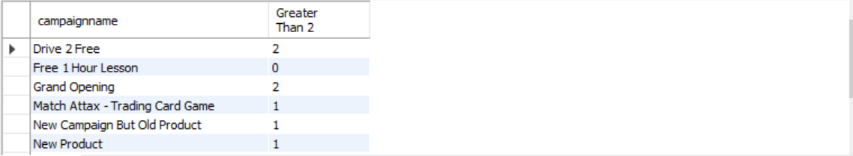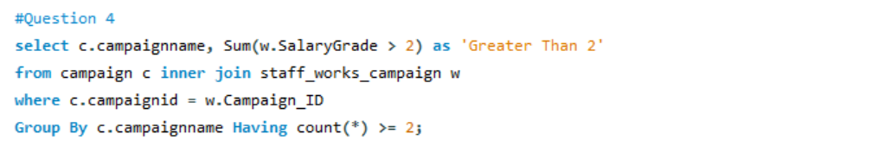

**Question 5**

